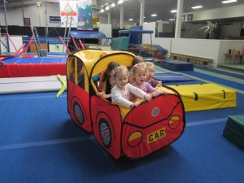
Toddler & Kindy Gym
Toddler gym (0-3.5yrs) Tues & Fri 9.15-10.15

Throughout the class there is group time and free exploration.
This class is a structured class with a coach, having different lesson plans each week.
These classes always require parent participation.

Kindy gym (3-5yrs) Tues & Fri 10.15-11.15
Kindy gym provides the opportunity for your child to experience and learn through movement.
Movement based activities – balancing, rolling, running, swinging, jumping and lots more. These activities assist your child’s development of coordination, confidence, creativity and self-esteem. Classes use all traditional gymnastics equipment
-Music and games suited to your child’s developmental needs.
-Different themes to spark your child’s interest

