Recreational Star Classes
Boys and Girls (4+yrs)
The aim of this program is to have continual activity and participation, which is varied, challenging and appropriate for the growth and development stage of a gymnast.
The program will contain the 4 “F’S” of gymnastics.
FUN, FITNESS, FUNDAMENTALS and FRIENDSHIP
The gymnast progresses through skills and works through
Zig Zag’s Club Based Program
STAR 1-3
KINDY
Introduction/Transitional Class
Suitable for girls and boys transitioning from
Kindy gym (morning classes) OR
Gymnasts (3/4yrs) with no gymnastics experience
Wednesday,
3.45-4.45pm
STAR 1
Suitable for girls with no gymnastics experience
Ages between 5-7yrs
Tuesday, Friday
3.45-4.45pm

STAR 2/3
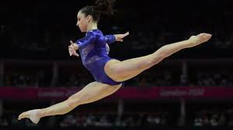
Suitable for girls with solid basic skills
Tuesday3.45-5.15pm, Wednesday 4.45-6.15pm

Seniors rec
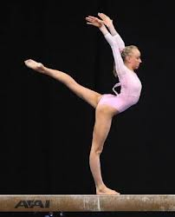
Suitable for girls ready for advanced skills
Tuesday, 5.15 – 7.15pm

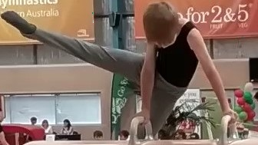BOYS GYM
Suitable for all boys
Boys who do gymnastics benefit from:

- Builds strength and prepares the body for the challenges in life

- Enhances co-ordination and agility, allowing the body to move like lightning

- Develops posture and confident body movement, including the ability to land safely

- Challenges the mind and body to reach new goals

- Develops healthy minds and bodies for now and later life
- Wednesday 4.45-6.45pm 5+ yrs
- SQUAD Training Monday+ Wednesday
- ADULTS GYM

- Adult Gymnastics Boot Camp
  - Fun, Fitness, Basic Gymnastics, and Trampolining with Coach Naomi

- Wednesdays starting from 22nd July
- Casual Cost $10 per class
- Time 7:00-8:00pm
    - 